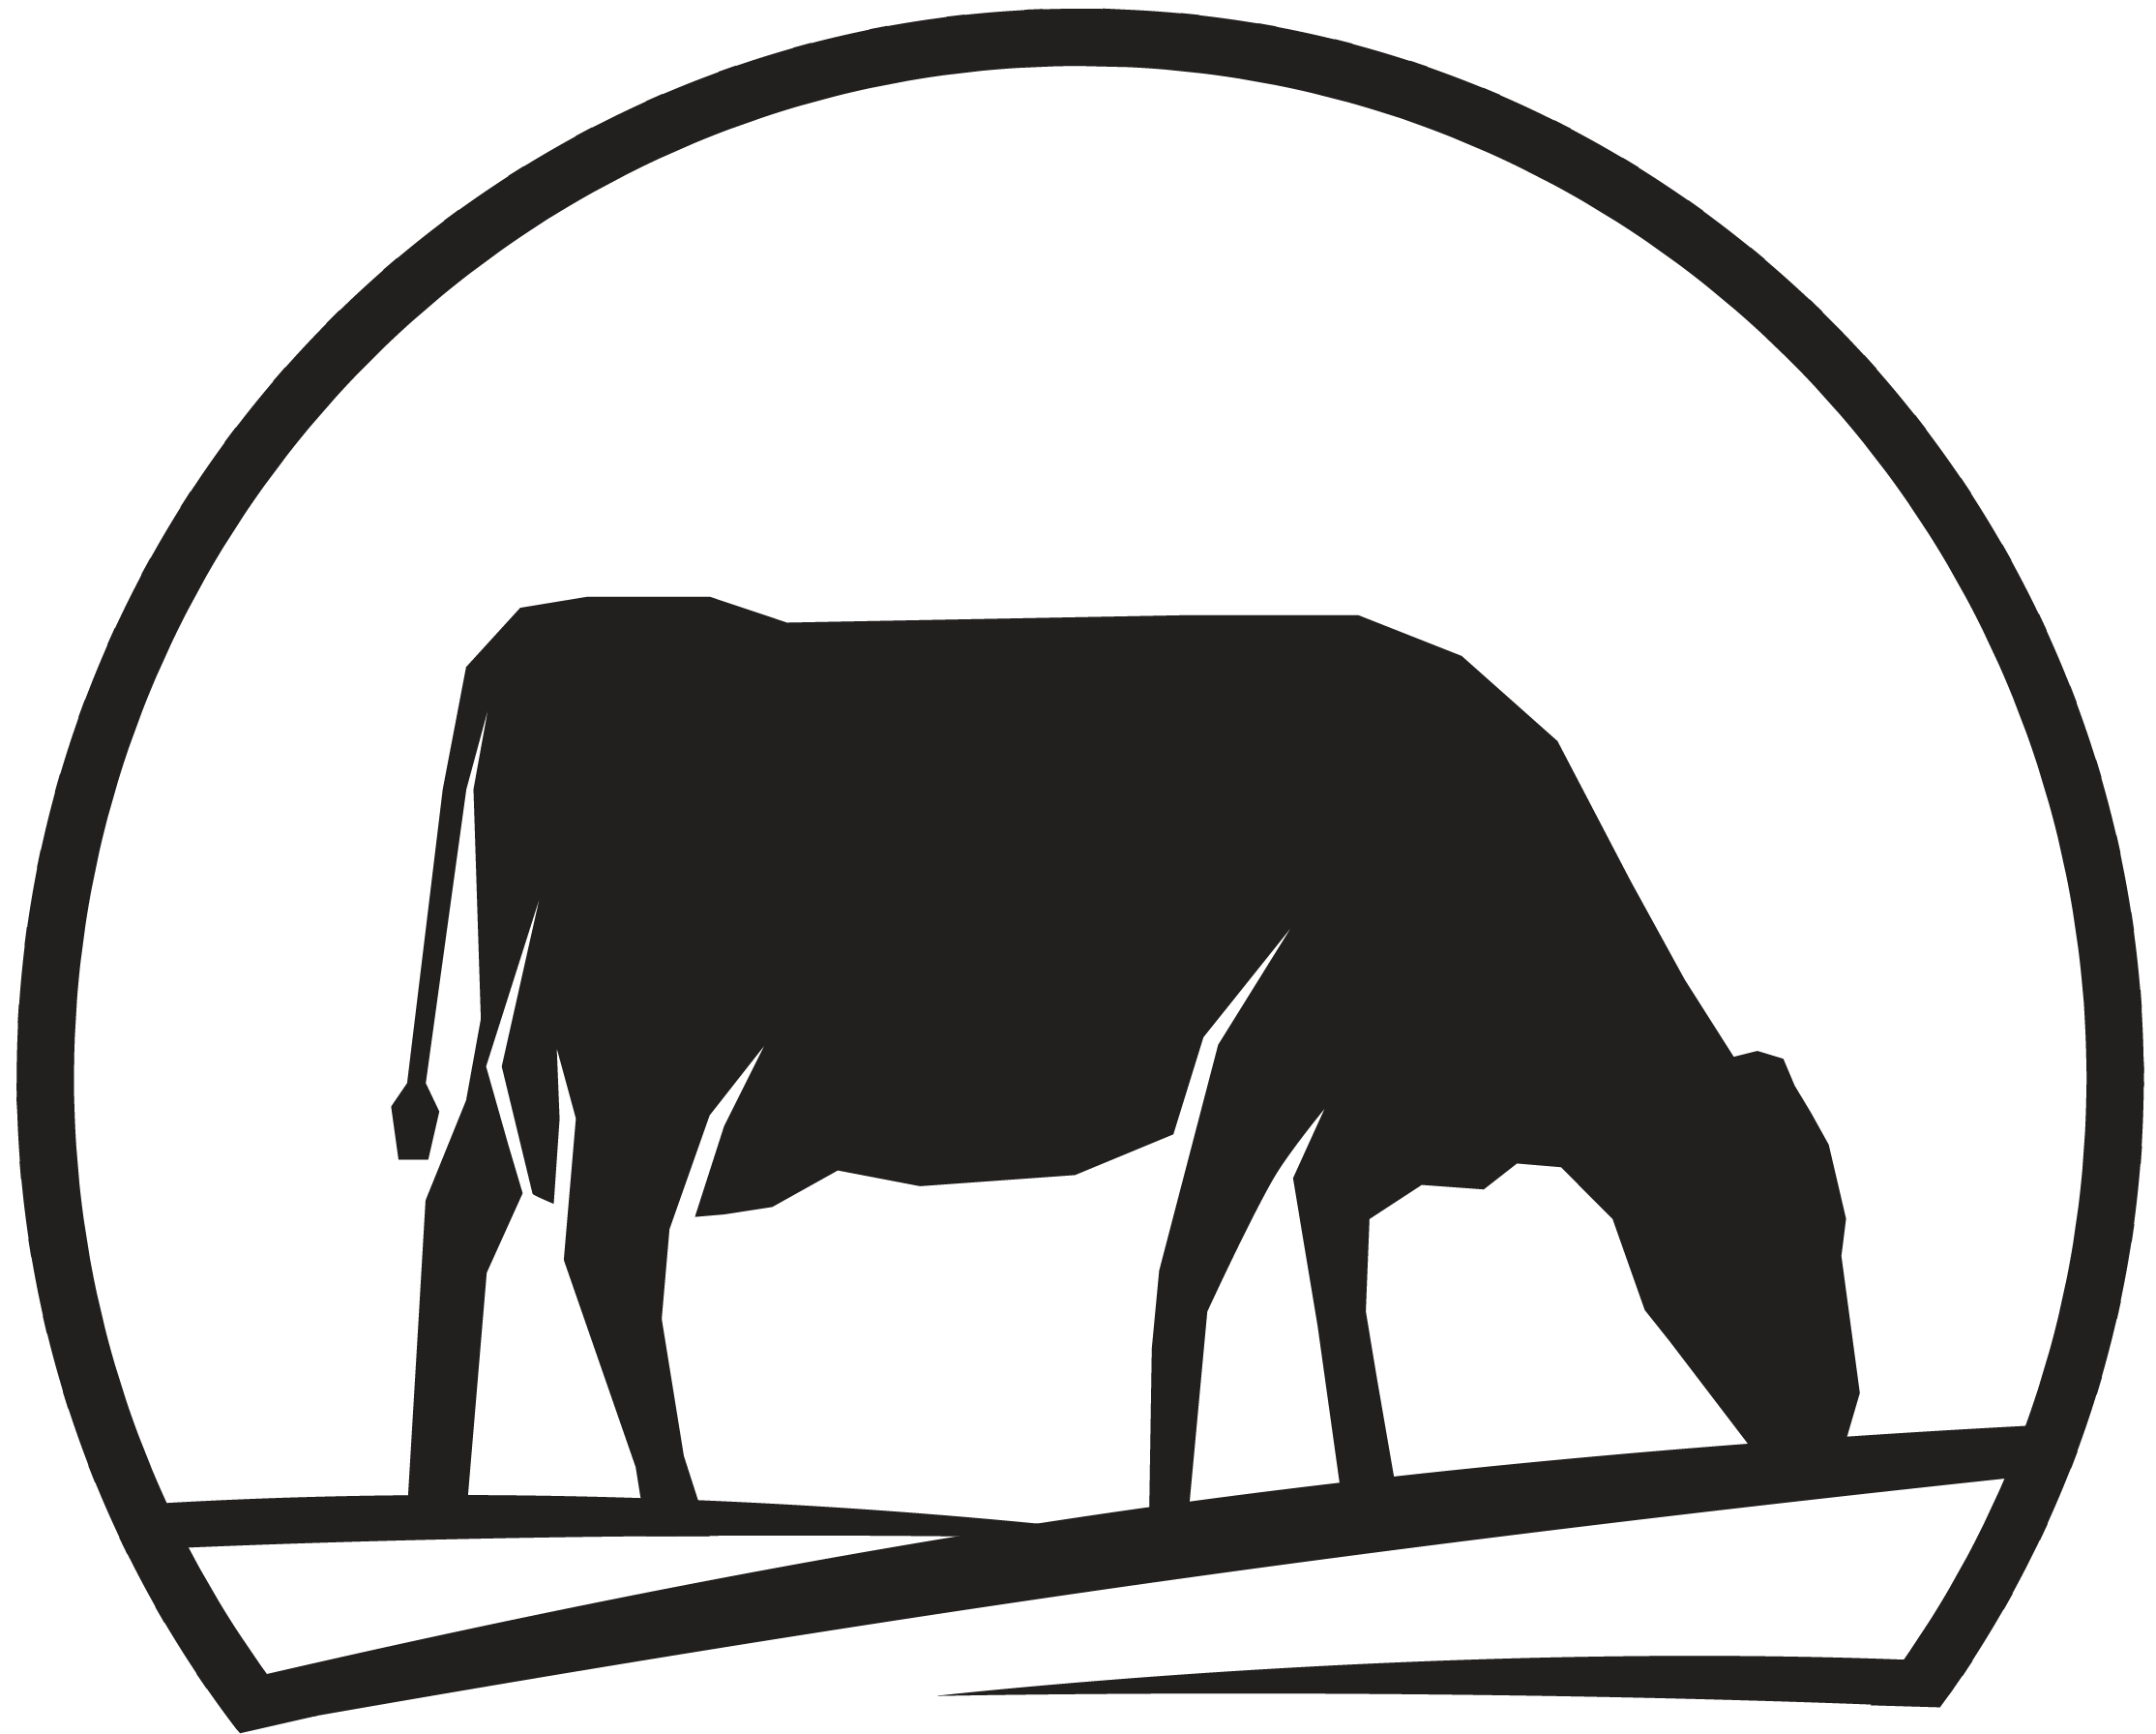 | ASB Alumni of the Year Award Entry Form  Please complete and email it to admin@nzdia.org.nz
Contact Details
Entrant 1 Name | Entrant must be an alumni and principals in the farming business the loan would be for
Entrant 2 Name | Max of two entrants
Partner (if applicable) | NZDIA include a max of two people for flights accommodation etc.
Business Entity Name
Business Address
Postal Address
Entrant 1 Phone
Entrant 2 Phone
Email

Previous NZDIA Participation
Participation Details | Details
Year(s) of Participation
Award(s) or Category Entered
Placement or Achievements
Roles held at regional or national level

Farm Data
Farm Information | Details
Business Trading Name
Current Position
Equity Percentage
Dairy Company Supplied
Supply Number
Farm Effective Area (ha)
Runoff Effective Area (ha)
Cows In Milk as at 01/11/2024
Estimated Production to 31/05/2025 (kg/MS)

Compliance Declaration
Compliance Check | Details
Have you (or any entity you have been associated with) ever been investigated, charged, warned, or convicted by any relevant authority? | [Yes/No] If Yes, provide details:
Are there any matters that could bring your reputation, the awards program, or sponsors into disrepute? | [Yes/No] If Yes, provide details:
I can confirm there is an on-farm Health & Safety policy | [Yes/No]

Entry Declaration
In submitting this Entry Form, I declare that the information provided is true, accurate, and complete. I accept the Conditions of Entry for this awards programme as posted on the New Zealand Dairy Industry Awards website: dairyindustryawards.co.nz. I understand that providing false or misleading information, failing to declare any material matter, which includes failing to declare a matter which may adversely affect the reputation of the Awards or the Trust, or submitting falsified documents may result in disqualification, termination of my entry at any stage at NZDIA's sole discretion, and/or forfeiture of any awards or prizes, including after winners have been announced. This may result in awards being withdrawn and prizes reclaimed. NZDIA further reserves the right to exclude any person from participating in the Awards on reasonable grounds, at its sole discretion. NZDIA reserves the right to refuse to award any prize to an entrant who NZDIA decides (in its sole discretion) may pose a reputational risk to the Awards or to its sponsors; gained unfair advantage in participating in the awards; or won using fraudulent or dishonest means.

Final Declaration
I confirm that the information provided is true, accurate, and complete. I accept the Conditions of Entry for this awards programme as posted on the NZ Dairy Industry Awards website.
Entrant Signature: _______________________
Date: _______________________

